1. Create a flowchart to demonstrate how the molal volume of a gas changes with pressure at a constant temperature.
2. 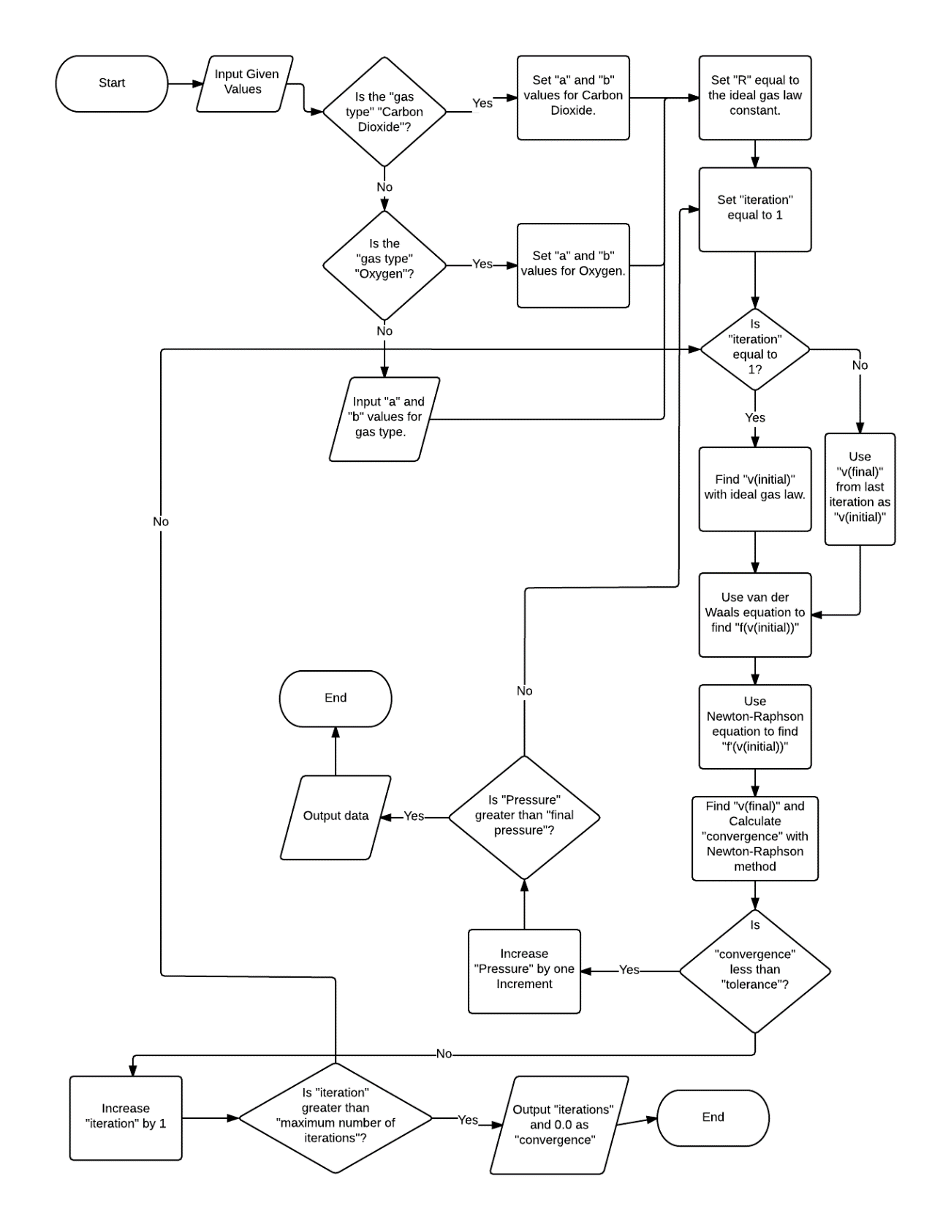Low Detail Flowchart
3. High Detail Flowchart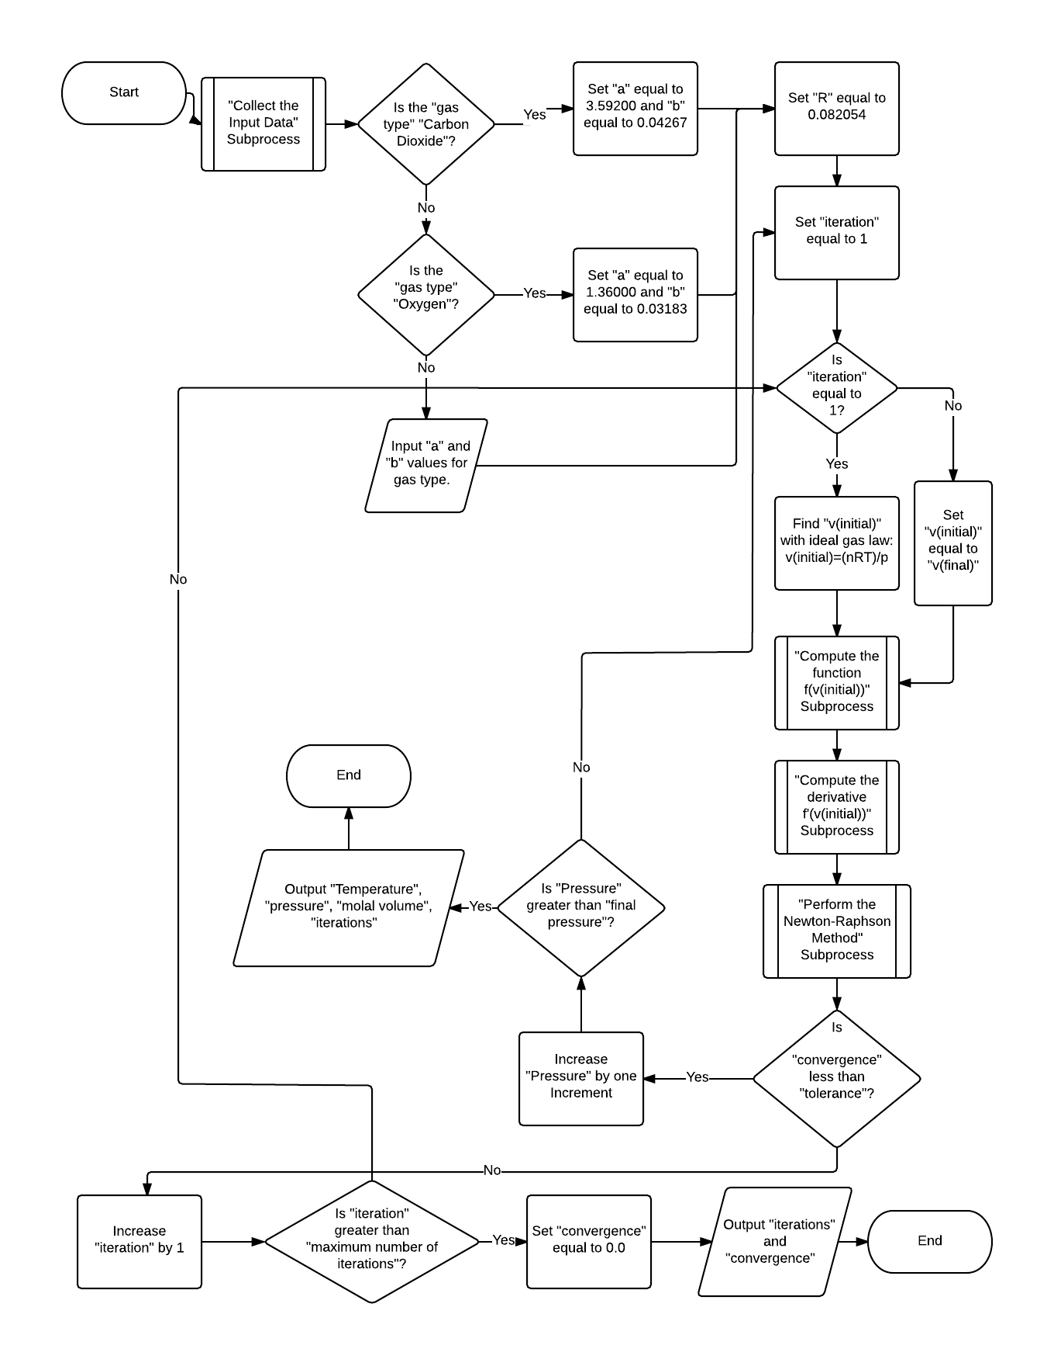
4. Sub-process Flowcharts
   1. 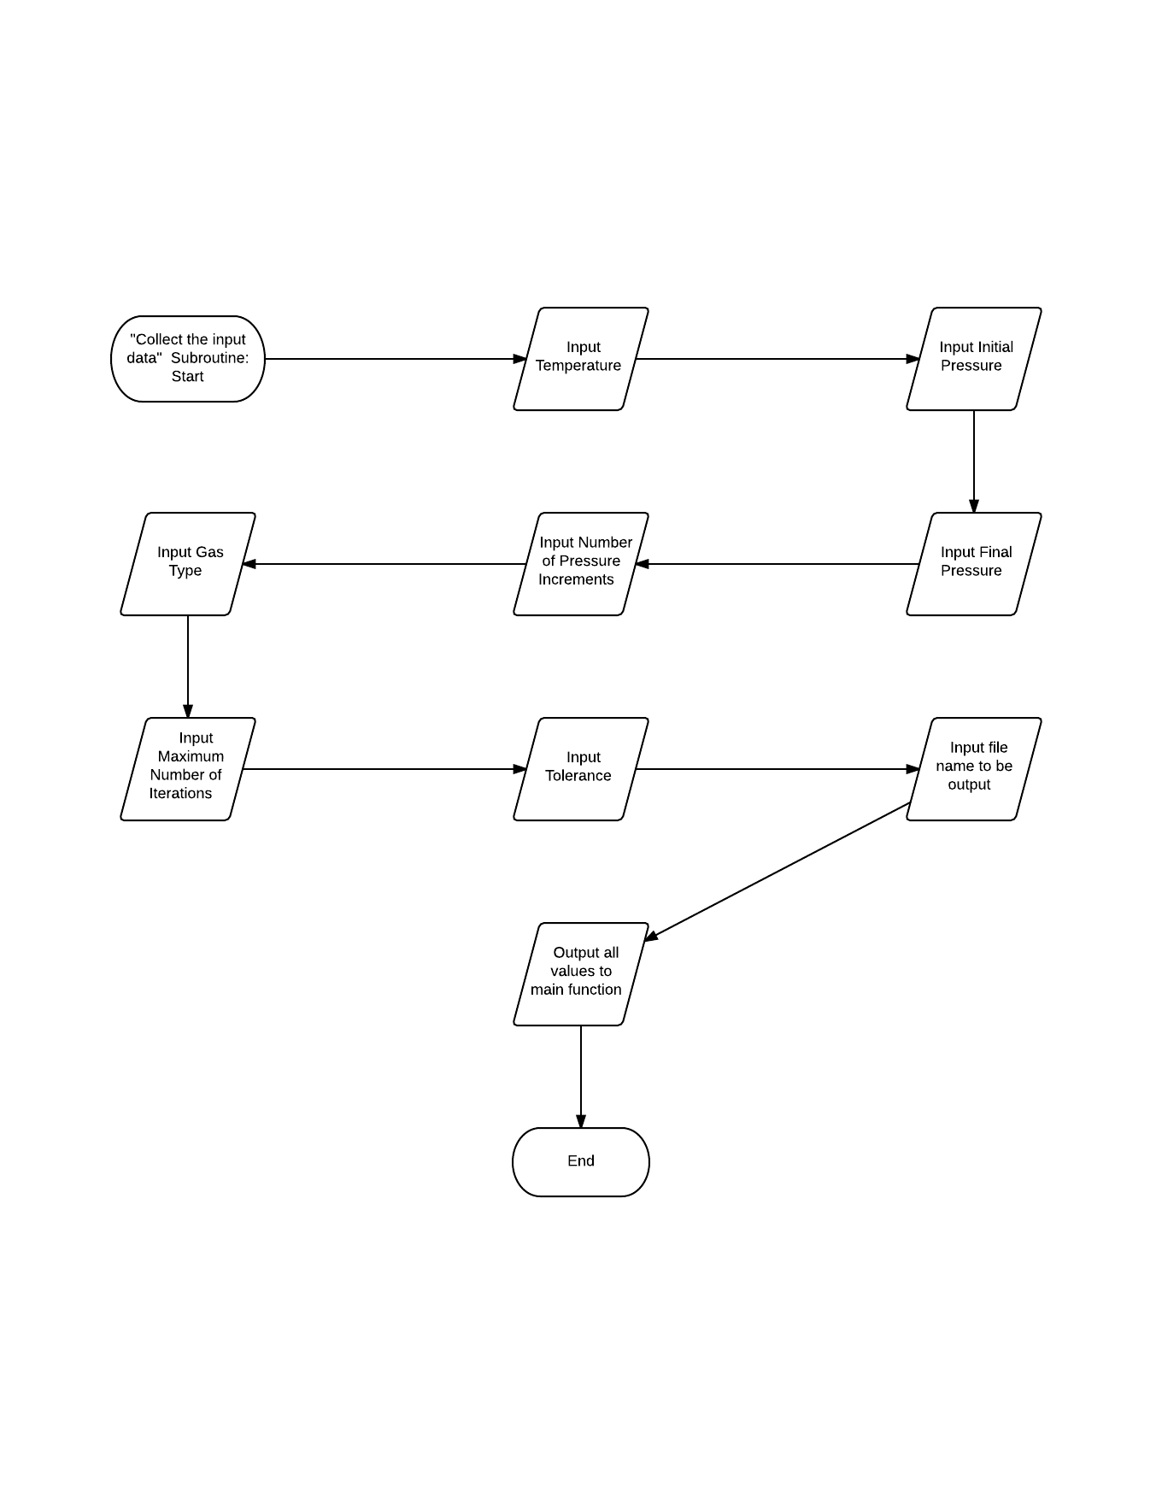Collect the Input Data
   2. Compute the Function f(v(initial))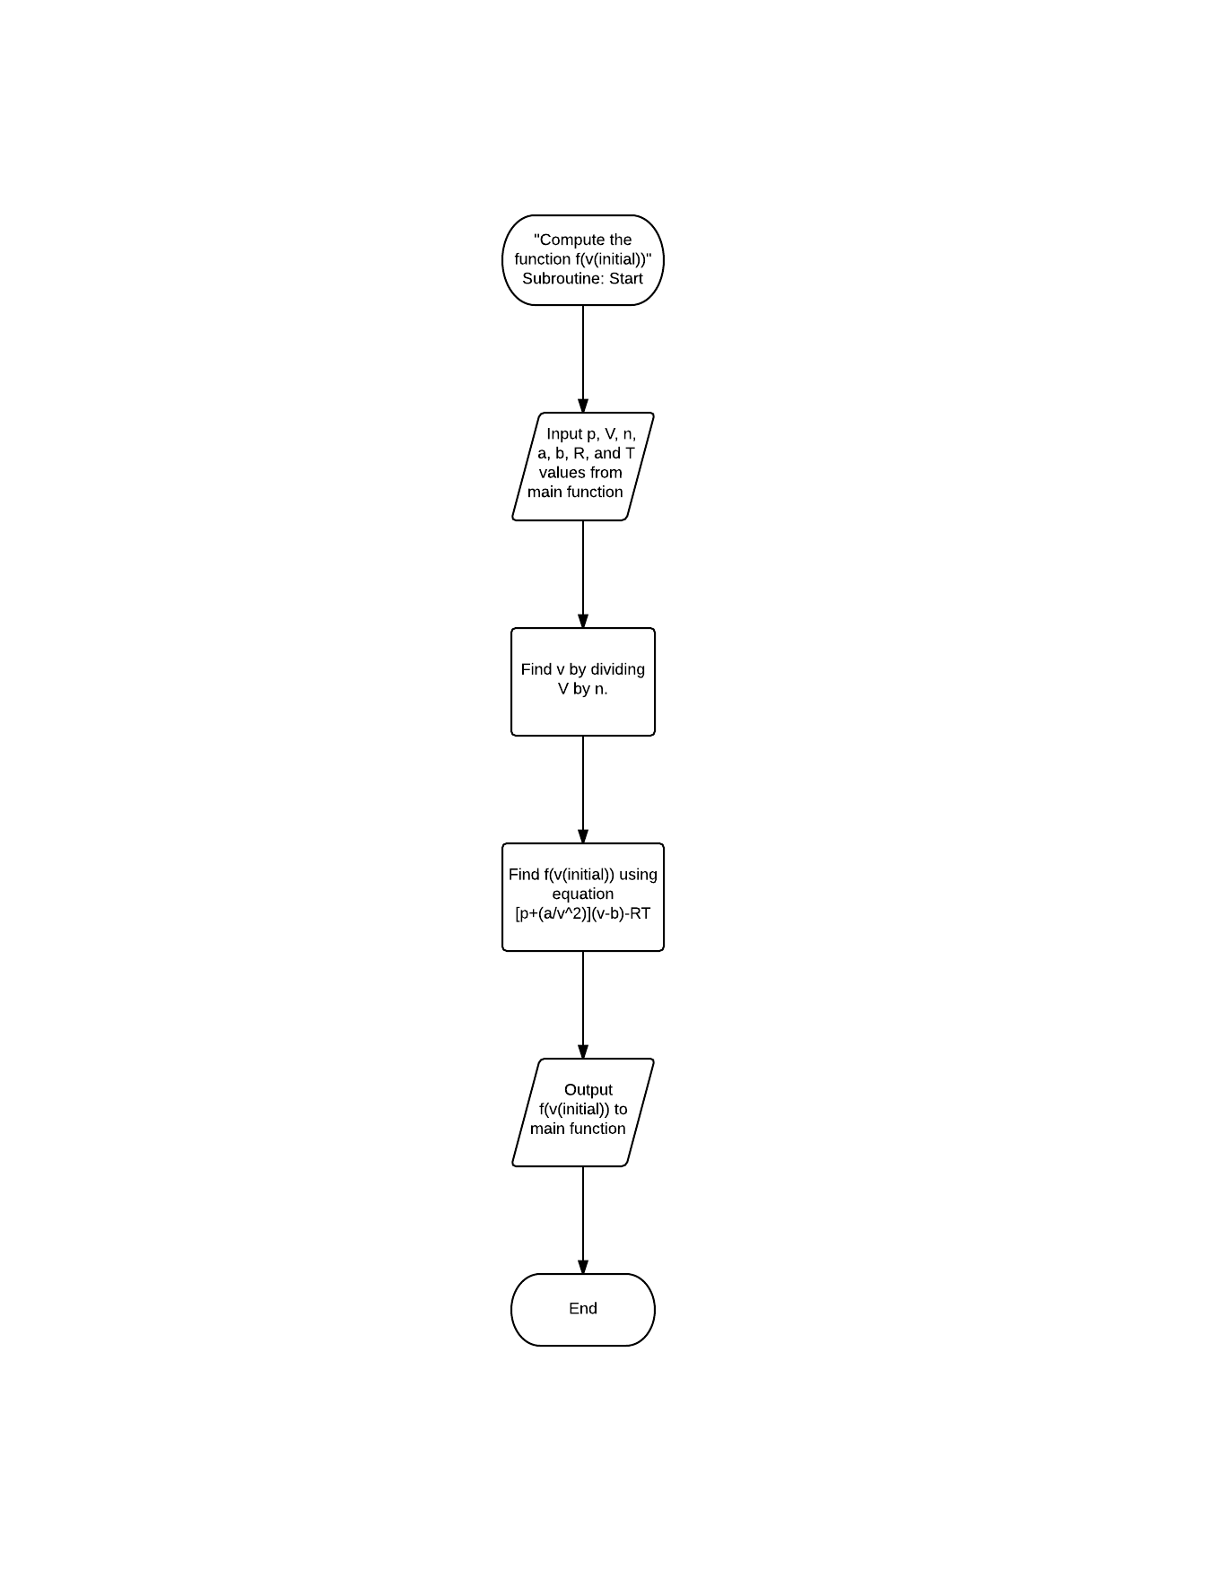
   3. Compute the derivative f’(v(initial))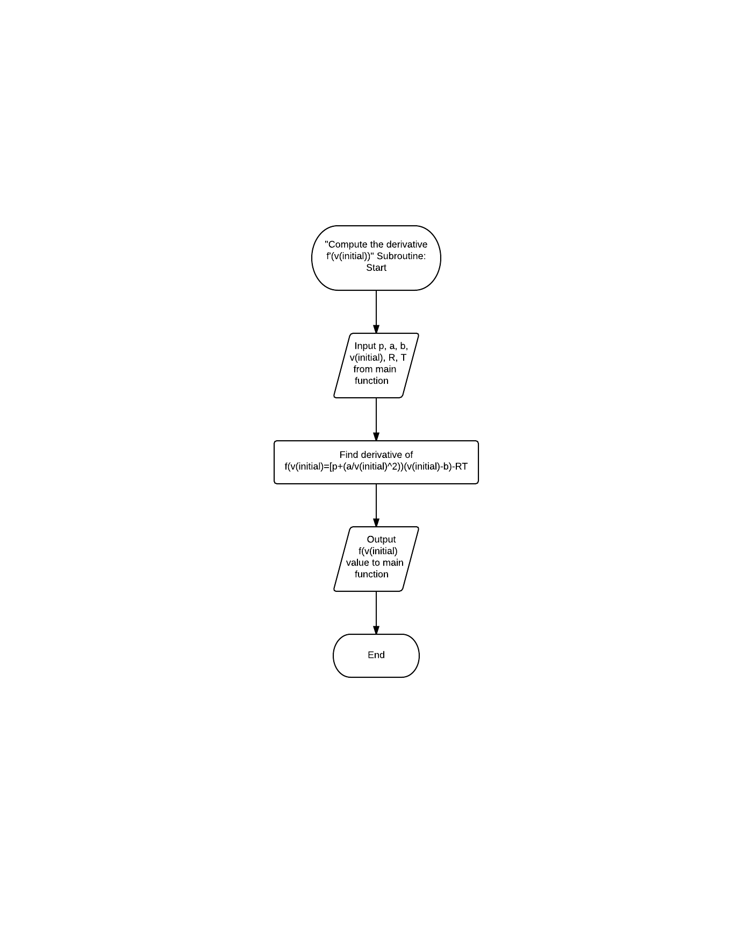
   4. Perform the Newton-Raphson method (including the convergence check)